CS 405 Module Five Encryption Activity
Kylie Reiter
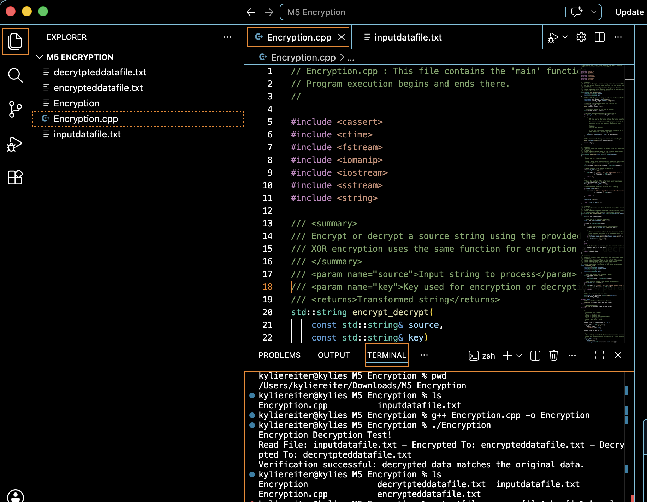
I began by reviewing the starter code and identifying the three TODO sections that needed to be completed. The first task was implementing XOR encryption. I modified the encryption loop so that each character in the source string is XORed with a character from the password key. I used the modulo operator (i % key_length) so the password repeats correctly when the input file is longer than the key.
Next, I completed the read_file() function by opening the input file with an input file stream and reading the entire file into a string using a string stream. I added error checking to make sure the file could be opened successfully before attempting to read it.
I then completed the save_data_file() function by writing the student's name, the current date in yyyy-mm-dd format, the encryption key, and the encrypted or decrypted data to the output file. The file is opened in binary mode and uses write() to preserve all encrypted characters.
During debugging, I verified that the program could locate the input file, compile successfully, and generate both output files. I also compared the decrypted output with the original input and confirmed that they matched exactly. The console displayed a verification message indicating that the encryption and decryption process worked correctly.

